
RAMAIAH
Institute of Technology
USN | 1 | M | S

(Autonomous Institute, Affiliated to VTU)
(Approved by AICTE, New Delhi & Govt. of Karnataka) Accredited by NBA & NAAC with ‘A’ Grade

SEMESTER END EXAMINATIONS – JANUARY 2020

Program | : | B.E.: Electrical and Electronics Engineering | Semester | : | V
Course Name | : | Linear Integrated Circuits | Max. Marks | : | 100
Course Code | : | EE54 | Duration | : | 3 Hrs

Instructions to the Candidates:
- Answer one full question from each unit.

 |  | UNIT- I
1. | a) | Define typical output impedance for an operational amplifier. Also, explain the effect of feedback factor on the output impedance of a  - Voltage follower  - Inverting amplifier  - Non-inverting amplifier. | CO1 | (06)
 | b) | Determine the output voltage for the open loop difference amplifier circuit given in fig. 1(b), if V_{in1} = 7.07mV_{rms} and V_{in2} = 14.14mV_{rms} (sinewave AC input)Draw the input and output waveform for both the cases. Op-amp used is 741 op-amp with a supply voltage of + 15V (open loop gain of op-amp is 2,00,000)  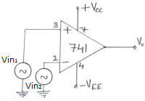  Fig. 1(b) | CO1 | (04)
 | c) | A 1kΩ load is to have 2V developed across it from a 15V source. Design  - A potential divider circuit such that V_{L} is derived directly from V_{CC} (fig. 1(c)(i)).  - A voltage follower is connected between the potential divider and R_{L} (fig. 1(c)(ii)). Calculate load voltage variation in each case, when the load resistance varies by -15%. Use a 741 Op-Amp.  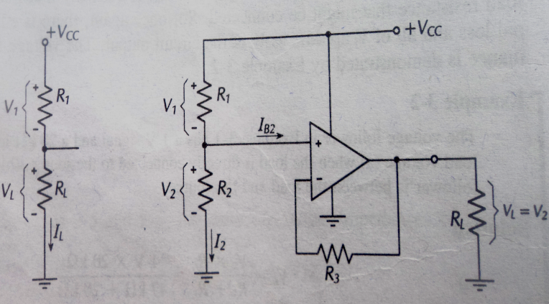  Fig. 1(c)(i) Fig. 1(c)(ii) | CO2 | (10)
2. | a) | List the characteristics of an ideal op-amp. | CO1 | (04)
 | b) | A LF353 BIFET Op-Amp is used in a non-inverting amplifier with a voltage gain of 100. Calculate the typical output voltage that would result from common mode input with a peak level of 100mV.  (From LF353 data sheet CMRR_{TYP} =100dB). | CO1 | (06)
 | c) | A direct coupled non inverting amplifier with a + 15V supply is to produce maximum possible output voltage and is to have a voltage gain of 60dB. The amplitude of the input voltage is to be 5mV AC. Using 741 Op-Amp, design a suitable circuit. Ensure that the circuit is suitably compensated for I_{B}R_{B} drop. Draw the circuit diagram with the component values mentioned on it. Also calculate the input and the output impedance for the circuit designed.  (From 741 data sheet: typical open loop gain=200000; typical open loop input impedance = 2MΩ; typical open loop output impedance=75Ω). | CO2 | (10)
 |  | UNIT- II
3. | a) | A capacitor coupled inverting amplifier is to have a +24V supply, a voltage gain of 10, an output amplitude of 3V, a lower cut off frequency of 50Hz, upper cutoff frequency=10kHz and a load resistance of 10kΩ. Design a suitable circuit using a 741 op-amp. Draw the circuit diagram with component values mentioned on it. Also draw the input waveform, output of the op-amp waveform (usually termed as V₀|) and output of the circuit waveform (V₀). | CO2 | (10)
 | b) | What do you mean by precision diode? With a neat sketch, show how a non-saturating precision half wave rectifier can be modified to obtain two independent half wave rectified output. Draw the waveform and explain the circuit operation. | CO2 | (10)
4. | a) | With a neat sketch, explain the working of high input impedance non inverting amplifier. Derive an expression for the input impedance of the circuit. Write equations for calculating component values using 741 and LF353 op-amp. | CO2 | (10)
 | b) | A 300kHz signal with a peak amplitude of 500mV is to be full wave rectified and amplified to 5V. Design a suitable circuit using BIFET LF353 op-amp with a supply voltage of + 15V. Sketch the circuit with component values mentioned on it. | CO2 | (06)
 | c) | With a neat circuit diagram, show how a half wave non saturating precision rectifier combined with a summing circuit to produce a full wave precision rectifier. | CO2 | (04)
 |  | UNIT- III
5. | a) | With a neat sketch explain the working of RC phase shift oscillator. Discuss the steps required to design the oscillator. | CO2 | (08)
 | b) | (i) Design a narrow band pass filter so that the center frequency f_{c} = 1 KHz, Q = 3 and A_{F} = 10.  (ii) Redesign the circuit by changing the center frequency to 1.5 KHz and keeping A_{F} and the bandwidth constant.  Draw the circuits with component values mentioned on it. | CO2 | (07)
 | c) | Design a wien bridge oscillator for an oscillating frequency of 2 kHz. Draw the circuit with component values mentioned on it. | CO2 | (05)
6. | a) | Show how two op-amp dead zone circuits can be combined with a summing circuit to produce precision limiting on both positive and negative half cycles of the output waveform. Draw the voltage waveforms throughout the circuit and explain its operation. Discuss the design procedure with equations for determining the value of each component. | CO2 | (10)
 | b) | A + 1.5V signal is to be sampled by a sample and hold circuit. The holding time is to be 700µs, and the output accuracy is to be approximately 0.3%. LM108 op-amps are to be used, and the available FET has a 25Ω channel resistance and a 300nA gate – source reverse leakage current. Design the circuit and determine the minimum acquisition time. Draw the circuit with component values mentioned on it. (For LM108 data sheet I_{B (max)} = 2 nA) | CO2 | (10)
 |  | UNIT- IV
7 | a) | With the circuit diagram and waveform explain the working of a non inverting voltage level detector. Plot the hysteresis curve for the same. If the same circuit have to be used for different UTP & LTP what modification need to be made? Draw the modified circuit with waveform? | CO2 | (10)
 | b) | Explain miller effect. Derive the equation relating the input capacitance of an inverting amplifier to the capacitance connected between input and output terminals. | CO3 | (05)
 | c) | Show how feedback in an non inverting amplifier can produce instability. | CO3 | (05)
8 | a) | Define gain bandwidth product and discuss its application to inverting and non inverting amplifiers. | CO3 | (05)
 | b) | Sketch the circuit of a lead compensation network. Explain its operation and show how it affects operational amplifier frequency response. | CO3 | (05)
 | c) | Design an inverting Schmitt trigger with V_{UT} = 3V and V_{LT} = 1V. Use 741 Op-amp with a Supply voltage of + 15V. Draw the circuit with component values mentioned on it and also draw the expected input and output waveform and Plot the hysteresis curve for the same. | CO2 | (10)
 |  | UNIT- V
9. | a) | With a neat sketch, explain the working of voltage to current converter with floating load. Derive an expression for the output current. Bring out the applications of voltage to current converter with floating load. | CO4 | (10)
 | b) | Design an astable multivibrator for a duty cycle of 50%. The free running frequency is 5kHz. Draw the circuit with component values mentioned on it. | CO5 | (06)
 | c) | Using 7805C voltage regulator, design a current source that will deliver a 0.25A current to a 48Ω, 10W load. Also calculate the minimum input voltage. Draw the circuit with component values mentioned on it. | CO5 | (04)
10. | a) | Design a differentiator to differentiate an input signal that varies in frequency from 10Hz to 900Hz. Draw the circuit diagram with component values mentioned it.  If the sine wave input of 1V peak value at 900Hz is applied to the differentiator designed in part (i), calculate its output voltage and plot its input and output waveform. | CO2 | (10)
 | b) | - Bring out different applications of 555 timer.  - With a neat sketch, explain how a pulse stretcher can be designed with a monostable multivibrator using 555 timer. | CO5 | (06)
 | c) | Bring out the difference between monostable and astable mode of the 555 timer. | CO5 | (04)

****************

